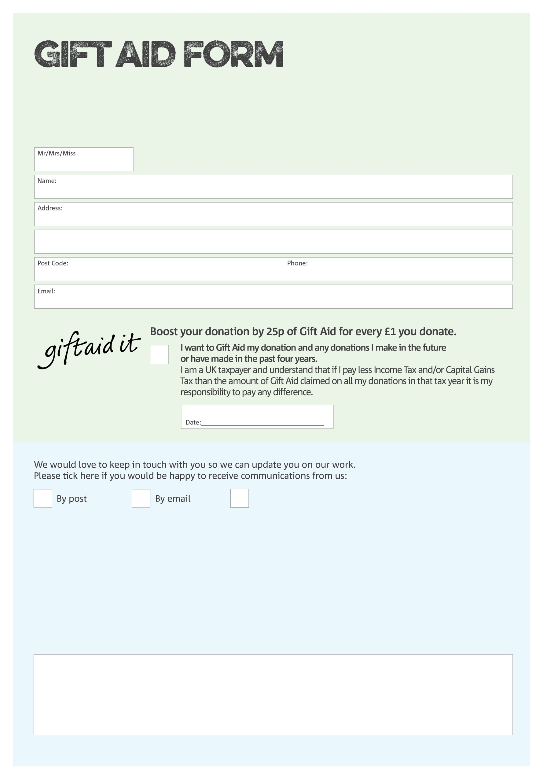

By filling in this form Newark Foodbank will receive an extra 25p for every £1 you give at no extra cost to you. Thank you!

You can change your preferences any time by contacting us on 07307 695310 or emailing us at datamgr@newark.foodbank.org.uk

I do not wish to receive future communications

from Newark Foodbank

**Data protection**

*Newark Foodbank is committed to protecting your privacy and will process your personal data in accordance with current Data Protection legislation. Newark Foodbank collects information to keep in touch with you and supply you with information relating to our work. To unsubscribe from our newsletter, send a message to the email address above with the word unsubscribe in the subject line. A full data privacy statement for financial donors is available from the foodbank on request.*

We would love to know why you have chosen to donate to Newark Foodbank. If you would like to share your motivation let us know below:

Charity Number 1160698. Registered in England & Wales