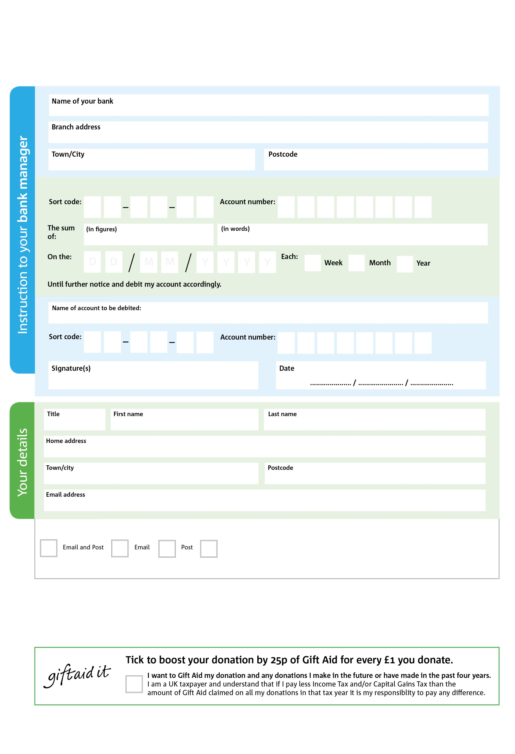

Reg. Charity No: 1160698 | Reg. in England & Wales

POST to: Newark Foodbank, 21 Carter Gate, Newark, NG24 1UA

2

V

1

V

8

V

5

V

0

V

4

V

9

V

1

V

**Please pass this form on to Newark Foodbank, using the address at the bottom, who will save a copy for their records.   
They will then send it onto your named bank or building society.**

3

2

0

1

4

5

We would love to keep you up to date with information about Newark Foodbank. Please tick your preference:

You can change your preferences any time by contacting us on 07307 695310 or emailing us at datamgr@newark.foodbank.org.uk

I do not wish to receive future communications from Newark Foodbank

Please pay **Newark Food Bank**

**Data protection**

*Newark Foodbank is committed to protecting your privacy and will process your personal data in accordance with current Data Protection legislation. Newark Foodbank collects information to keep in touch with you and supply you with information relating to our work. To unsubscribe from our newsletter, send a message to the email address above with the word unsubscribe in the subject line. A full data privacy statement for financial donors is available from the foodbank on request or from our website*

**Standing Order Mandate**

**newark.foodbank.org.uk**

You can change your preferences any time by contacting us on XXXXXXXXXXX or emailing us at XXXX@XXXXXXXXXX.foodbank.org.uk

I do not wish to receive future communications from XXXXXX Foodbank